Volume

1

KU Varsity Hackers

shelf

User

Manual

KU VARSITY HACKERS

shelf User Manual

© KU VARSITY HACKERS

4101 W 24th St • APT 311

Lawrence, KS 66047

Table of Contents

* The Home Screen 1
* View on an iPhone 2
* Listing a book 2
* Borrowing a Book 5

Chapter

1

The Home Screen

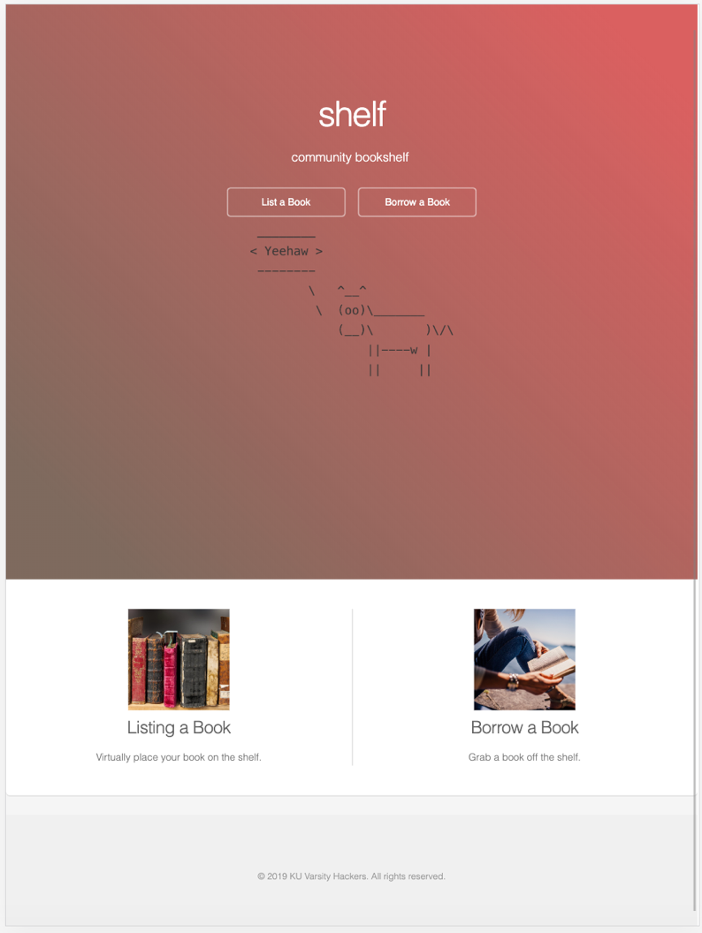

This is the home screen. As you can see it includes our wonderful cowsay logo. It is responsive and works on all browsers and devices as shown on an iPhone on the next page.

# View on an iPhone

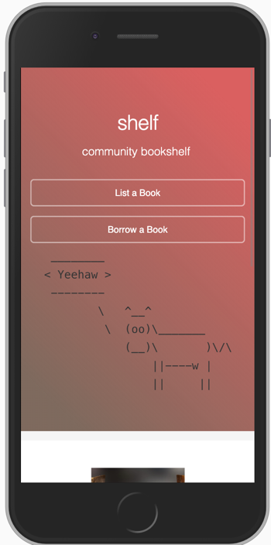

This home screen includes a description of what you can do and 2 buttons.

1st a button to list a book and secondly a button to borrow a book.

To list a book click List a book and follow the instructions in the next section.

# Listing a book

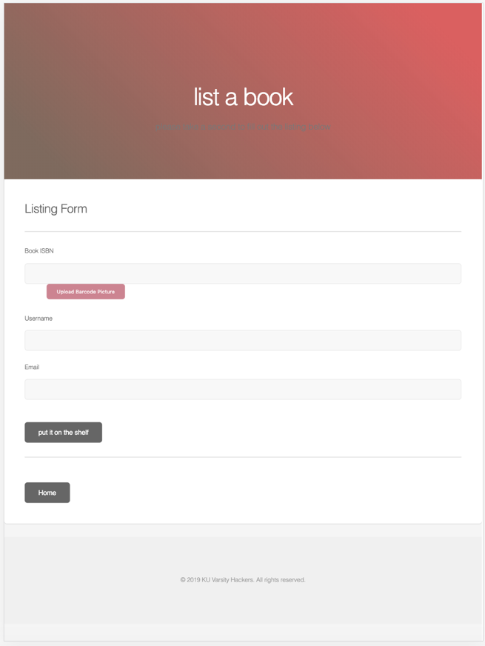

We start with the listing a book homescreen. We can then upload a picture of a barcode to automatically detect the barcode or type it in ourselves. On mobile we can take advantage of the built in camera and take a picture directly from the browser.

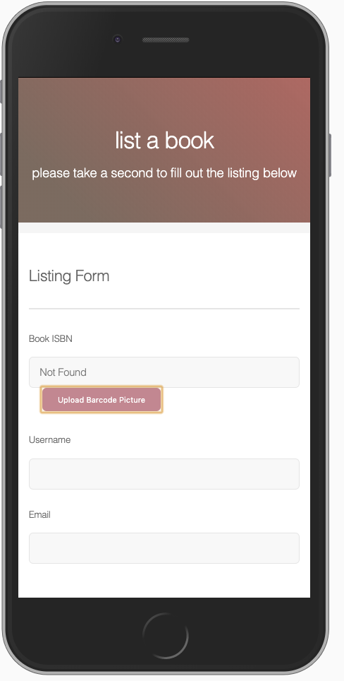

If the picture is not clear or far away, you will see the text Not Found under the ISBN. In this case you can refresh the page and try again with another photo or just type in the ISBN manually.

An example of a working image is included below



As you can see, even though there is some glare in the image, it still works. This is because of our extremely advanced barcode image dectection algorithms.

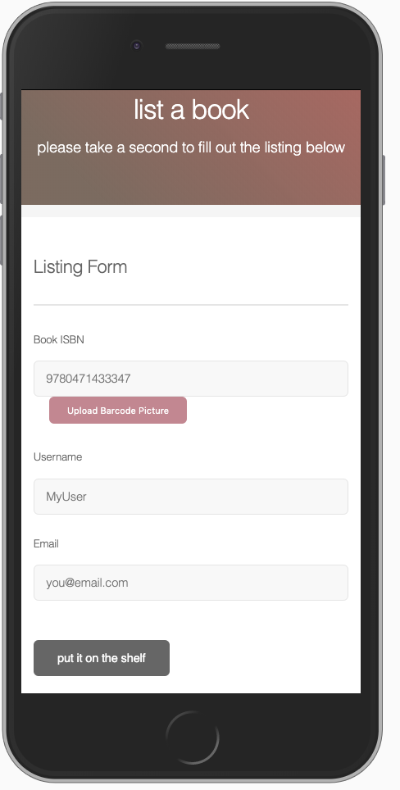

We have filled out the rest of the form below. Now you can hit put it on the shelf.

If the ISBN is from an actual book and your email address is valid, you will receive the following prompt indicating that all was successful.

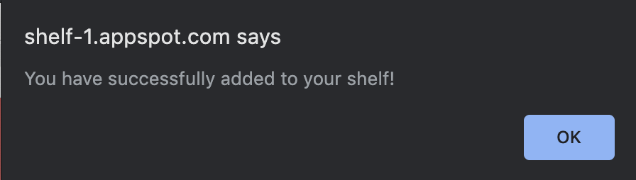

In the next section we will go through the process of borrowing a book.

# Borrowing a Book

To borrow a book first navigate to the borrow book page from the home screen

You should be greeted with a page like the following.

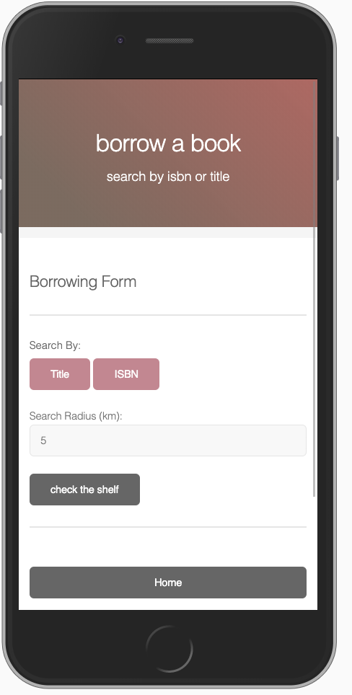

You can then click Title or ISBN to search for a book using either of those parameters.

We will try a search by title.

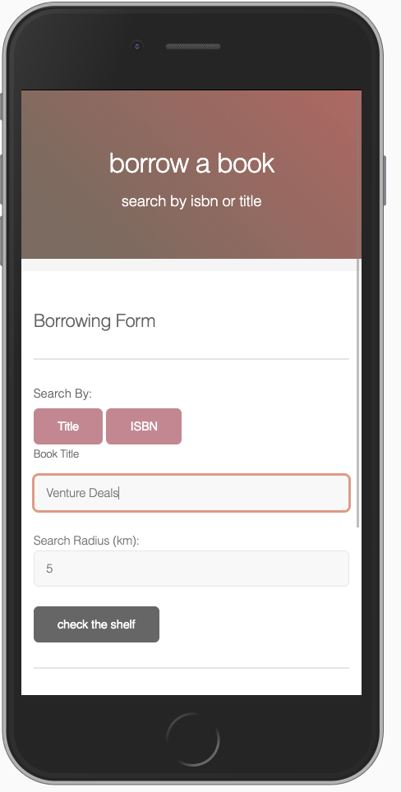

Here we are searching for the book Venture Deals.

You can increase or decrease the search radius as you please.

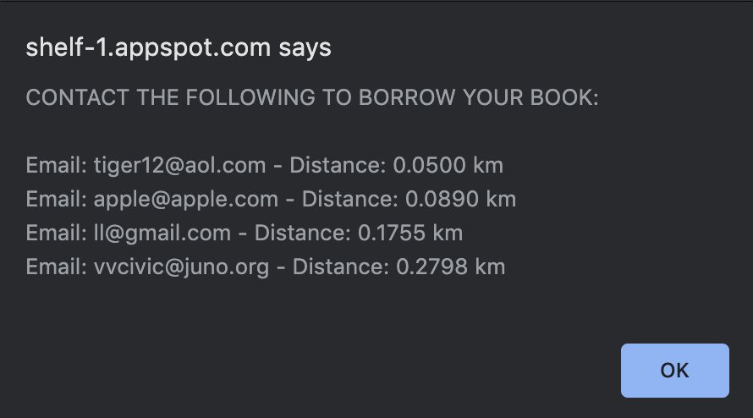

You will get back a list of emails coresponding to users who listed the book sorted in the order that they were most recently listed.

You can now send your email using your preferred mailing client.

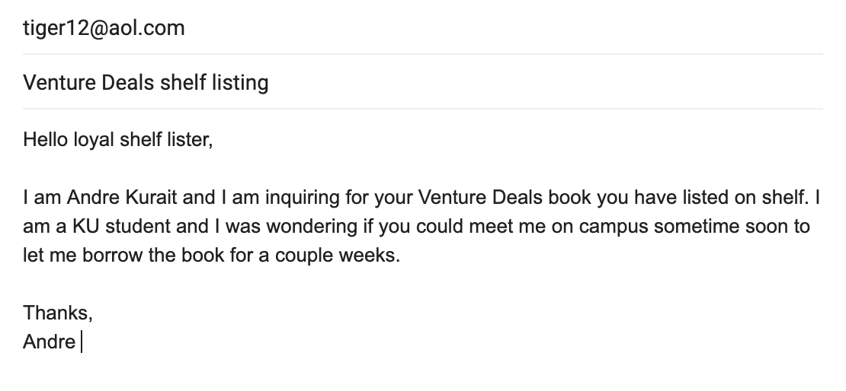

And there you have it, the full cycle of a book

The end.